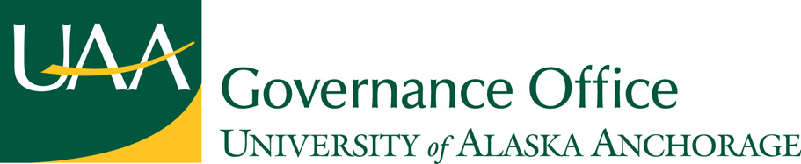

UAA Assembly

Request for Live Distance Testimony at Board of Regents Meetings
SPONSORED BY: University Assembly (representing students, faculty, and staff at UAA)

WRITTEN BY: Peter Finn

DATE: November 12, 2009

WHEREAS: The ability to testify at meetings of the board is essential for students, staff, and faculty to voice their legitimate concerns; and,

WHEREAS: The Board of Regents currently does not accept live testimony unless it is given in person; and,
WHEREAS: It is impossible for the board to visit every campus in a single year; and,

WHEREAS: Live testimony is far more effective than written or recorded testimony; and,

WHEREAS: It is inefficient and expensive for students, faculty, and staff to travel to board meetings in order to provide live testimony; and,

WHEREAS: Most small campuses cannot afford to send representatives to testify on critical issues; and,

WHEREAS: The board has the right and ability to accept live distance testimony at all of its regular meetings; and,

WHEREAS: The technology for live distance testimony is common and reasonably accessible at every campus; and,

WHEREAS: Students, staff and faculty have all expressed a strong desire to see the board accept live distance testimony at its regularly scheduled meetings.

THEREFORE BE IT HEREBY RESOLVED
That the University of Alaska Anchorage Assembly requests that the Board of Regents adopt a policy of accepting live testimony from students, staff and faculty who cannot be physically present at meetings.

THEREFORE BE IT HEREBY FURTHER RESOLVED
That a copy of this resolution be forwarded to the University of Alaska Board of Regents, Coalition of Student Leaders, Faculty Alliance, Staff Alliance, and System Governance Council.

Chair Date

